A000-Mex-Teotihuacan-Standing Figure-Feather Headdress–Ceramic-400-700 CE

Fig. 1. Teotihuacan-Standing Figure-Feather Headdress–Ceramic-400-700 CE

Case no.: 10

Accession Number: A1502

Formal Label: Teotihuacan-Standing Figure-Feather Headdress–Ceramic-400-700 CE

Display Description: This figure displays an elaborate feather headdress and earplugs. In 500 C.E. Teotihuacan, in central Mexico, was one of the largest cities in the world, with an estimated population of 150,000 so this élite individual was a very special individual. Teotihuacan’s culture, religion, and art spread throughout Mexico and Central America. LC Classification:  [F1301](http://librarycatalog.unh.edu/search~S5?/fF1301+.W85/ff++1301+w85/-3,-1,,B/browse)

Date or Time Horizon: 400-700 CE

Geographical Area: Teotihuacan

Map, GPS coordinates: [19°41′33″N 98°50′37.68″W](https://tools.wmflabs.org/geohack/geohack.php?pagename=Teotihuacan&params=19_41_33_N_98_50_37.68_W_type:landmark)

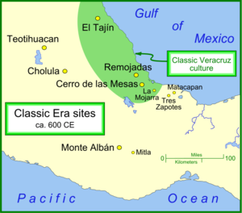

Fig. 2. Map of Teotihuacan and other important Classic Era settlements. From https://upload.wikimedia.org/wikipedia/commons/thumb/b/b9/Classic_sites_1.png/450px-Classic_sites_1.png

Cultural Affiliation: Teotihuacan

Media: ceramic

Dimensions:

Weight:

Condition: original

Provenance: unknown

Discussion:

This figure was found in the vicinity of one of the outlying settlements of Teotihuacan indicating that the concept of a hierarchical society had diffused from the center to the periphery.

Appendix:

AP.7